**Chapter 1**

**Introduction**

**Rationale**

Information portals are web-based platforms that serve as gateways to a variety of information and services. They are designed to provide users with easy access to relevant information, applications, and tools. Portals can be general-purpose, providing access to a wide range of information, or specialized, focusing on specific topics or industries. Such portals are designed with aesthetically pleasing user interfaces that offer many easy to use core features and cost-effective solutions. With elements such as a learning management system, news, notices, and real-time notifications, the educational portals provide a central point of communication between students, teachers and admins.

**Objectives**

* Information portal management system (IPMS) focuses on the basics of setting up and managing an effective information portal, providing key insights and strategies for maximizing its functionality and usefulness.
* It is a web-based platform that provides users with access to a variety of information, resources, and services. These systems are designed to organize and present information in a way that is easy to navigate and search.
* These systems typically provide tools for organizing content, managing user access, and customizing the portal's appearance and functionality.

**Web-based System**

* Allow users to access the portal from any web browser.
* Provide a dashboard for administrators to manage content, users, and permissions.
* Enable users to search for information using keywords, filters, and categories.
* Support multimedia content such as text, images, videos, and documents.
* Offer collaboration tools like discussion forums, chat, and notifications.
* Ensure responsive design for seamless access on different devices.

**Scope and Limitations**

Information portals have evolved significantly over the years. In the early days of the internet, portals primarily served as gateway sites that aggregated links to other websites. However, with advances in technology, portals have become more sophisticated, offering personalized content, social media integration, and advanced search capabilities.

Despite their benefits, information portals also present several challenges. These include ensuring the accuracy and relevance of information, managing user access and permissions, and integrating data from various sources. Additionally, portals must be regularly updated to keep pace with changing user needs and technological advancements.

**CEC School**

* Effective information portal management can lead to several benefits for school, including improved productivity, enhanced collaboration, and better decision-making.
* By providing easy access to information, portals can help organizations streamline their operations and achieve their business goals more efficiently.

**Web-based System what could do (ADMIN):**

* User Management
* Content Management
* Subject Schedule Management
* Courses Management
* Student Management
* Assignment Management
* View Users Activity

**Web-based System what could do (Teacher):**

* Student Management
* Assignment Management
* View Record Student
* Upload Student Grades

**Web-based System what could do (Student):**

* Update Information
* Submit/Update Assignment
* View Content
* View Records
* Can Evaluate Teacher Performance

**Significance of the Project**

An information portal typically consists of several key components, including a user interface, content management system, search engine, and security features. The user interface is designed to be intuitive and user-friendly, allowing users to easily navigate the portal and find the information they need. The content management system allows administrators to create, edit, and manage content on the portal. The search engine enables users to quickly find specific information, while security features protect sensitive information from unauthorized access.

**CHAPTER 2**

**REVIEW OF RELATED LITERATURE AND STUDIES**

**RELATED LITERATURE**

(Gunathilake, Indrathilake, & Wedagedera, 2009) proposed an opensource web based MIS for the University of Ruhuna, Sri Lanka. This they were able to implement with the LAMP/WAMP technologies. They were able to categorize their users based on administrator, super admin, top admin, general, lecturer and student. The pilot version was targeted at their Faculty of Science and they achieved a password encryption with the primary DES algorithm. 19

(Mariusz , 2010) in his solution University Study-Oriented System (USOS) in Poland stated that the main functional parts are the admin, web, admission/registration of students, database of results, course and diploma catalog, statistics etc. According to him, this solution is used by 27 higher education Polish institutions. In such a system, before transferring any module for production use it has to pass through sample database and university test. Documentation comprising system specification and implementation were updated regularly. Such solutions enhance communication between students and lecturers, proper security measures to prevent against Cross-site request forgery.

(Bharaagoudar, Geeta, & Totad, 2013) developed a web-based Student Information Management System in India which could send emails to students to validate their mailbox on registration. They were able to achieve this using technology such as HTML, CSS, Javascript, PHP and SQL. According to their description, it is a paperless work that assists in automating existing manual methods and can be remotely monitored and controlled on a server based network, the SIMS developed had no built-in security measures to prevent SQL injection.

(Hemn & Wu , 2014) proposed a system in China that can provide students’ general and educational information. According to them, the Students Information Management System (SIMS) can be used to create, read and update the details of a student and also generate reports about his/her skills and experience. Such systems save time of retrieval and prevent data loss.

An Information System (IS) can be any organized combination of people, hardware, software, communications networks, data resources, policies and procedures that stores, retrieves, transforms and disseminates information in an organization. (O'Brien & Marakas, 2011).

(Pinho et al. and Saghapour et al.) refer that web portals have revolutionized the way the academic community interacts and communicates [3,4]. Pinho et al. and Bawack and Kamdjoug argue that this technology enables the integration of all the institutional information, applications, and tools into a single system, thereby facilitating the procedures and changing the way of communicating, the working relationships, and the teaching and learning activities [3,5]. As mentioned by Pinho et al., the resistance to the implementation of these web tools can make information management and success of the HEIs increasingly difficult, i.e., the acceptance of the technology is fundamental for the successful use of these platforms [3].

Providing the best education to children is vital for their overall growth and development. As a result, parents take their time to know everything about the schools they have shortlisted for their child. They visit school websites and look for relevant testimonials before enrolling their kid in any school. A school website is crucial as it is the first point of interaction between schools and parents. That’s why schools need an impressive website with all relevant information to attract the attention of parents and potential students. The website for schools is a mirror for the school management as it affects their overall image and reputation. An impressive website containing relevant information is vital to increase the number of admissions to the educational institution ([DIVYANSH BORDIA](https://blog.teachmint.com/author/divyansh/), 2022).

Online education has transformed the way we approach learning, offering convenience, flexibility, and access to education for people from all walks of life. It has become a popular option for students of all ages, with online courses available from some of the world's top universities, covering a range of subjects and fields. However, with the widespread adoption of online education, there has been an ongoing debate about its impact on learning outcomes.

One of the main advantages of online education is the flexibility it offers. Students can access course materials and lectures at their convenience, and they can learn at their own pace. This means that people with busy schedules, such as working adults or parents, can fit education into their lives in a way that suits them. Online education also removes geographical barriers, allowing students from around the world to access courses from anywhere with an internet connection (Valentine Ubah, 2023).

Nowadays, technological advances in providing transformations in the school scenario, and one of them are the drastic change in secondary school management during the digital era. The purposes of this research were 1) to study the current situations and problems of secondary school management during the digital era; 2) to study the scenarios of secondary school management during the digital era in the next decade (2022-2031). The research specifically looked into 4 core missions of secondary school: 1) management of teaching and learning 2) personnel management 3) budgeting and 4) educational management. The research was conducted in 2 phases. Phase I: studying the current situations and the problems of secondary school management during the digital era by using a questionnaire to collect data from a sample group of 230 secondary school administrators. Phase II: studying the scenarios of secondary school management during the digital era in the next decade (2022-2031) using Ethnographic Delphi Futures Research (EDFR) for 3 parts. Part 1: Interviewing 19 experts using a semi-structured interview form and then analyzing and synthesizing the future tenders (scenarios). Part 2: Assessing the feasibility and the appropriateness of the scenarios by using a 5-level scale questionnaire. The statistics used were median and interquartile range. Part 3: Confirm trend scenarios of secondary school management during the digital era in the next decade (2022-2031). The findings revealed that the current situations of practice are all at a high level and the problems of the management are all at a moderate level. The scenarios of secondary school management during the digital era in the next decade (2022-2031) consist of 4 key elements and 40 possible trends, namely: 1) management of teaching and learning in the digital era with 15 possible trends; 2) educational personnel in the digital era with 10 possible trends; 3) budget in the digital era with 6 possible trends; and 4) educational management in the digital era with 9 possible trends (Thasai, Sakdadach; Sirisuthi, Chaiyuth; Aksornsua, Pha, 2023).

(Tubin, Dorit; Klein, Sarit 2007) Over the past few years, as part of the Information and Communication Technology (ICT) reform on the one hand, and the increased demands for school accountability on the other, more and more schools have launched a school website aimed at enhancing educational activities, supporting student-teacher communication, contributing to school marketing efforts, and fostering accountability to and collaboration with the school's constituency. A large body of research on ICT-based pedagogical and educational websites reveals the contributions of such websites to the schooling process. However, the phenomenon of school websites, which serve the school organization in its entirety, remains relatively unexplored. In this study, the authors explore the contents and structure of school websites and their responsiveness to their school's environment. They briefly review the literature regarding school websites, describe the institutional theory that provides the conceptual framework for the study, present the study methods and findings, and finally discuss the results and suggest practical implications for accountability-oriented school website development.

Management information systems (MIS) programs were developed to prepare graduates to create innovative solutions to problems where business and technology intersect. As such, the curricula must change rapidly to stay current with industry standards, an accelerating moving target. This research presents the findings of a systematic literature review to identify and present trends in the scholarly literature on MIS education. The purpose of this approach was to understand how academia ensures students are prepared for industry and keeps pace with changing industry needs. Key findings from the literature are presented, as well as a compilation of areas for future research. Overwhelmingly, a lack of international perspective was identified as the vast majority of articles collected data in the US. Further, the direction of future research and exploration revolved around five themes of innovative pedagogical approaches, industry partnerships, subtopics of MIS education, new methods and metrics for measuring success in MIS education, and cross-disciplinary opportunities in fields such as mathematics, traditional business disciplines, and the hard sciences (Elrod, Cassandra C.; Stanley, Sarah M.; Cudney, Elizabeth A.; Hilgers, Michael G.; Graham, Cameron , 2022).

**RELATED STUDIES**

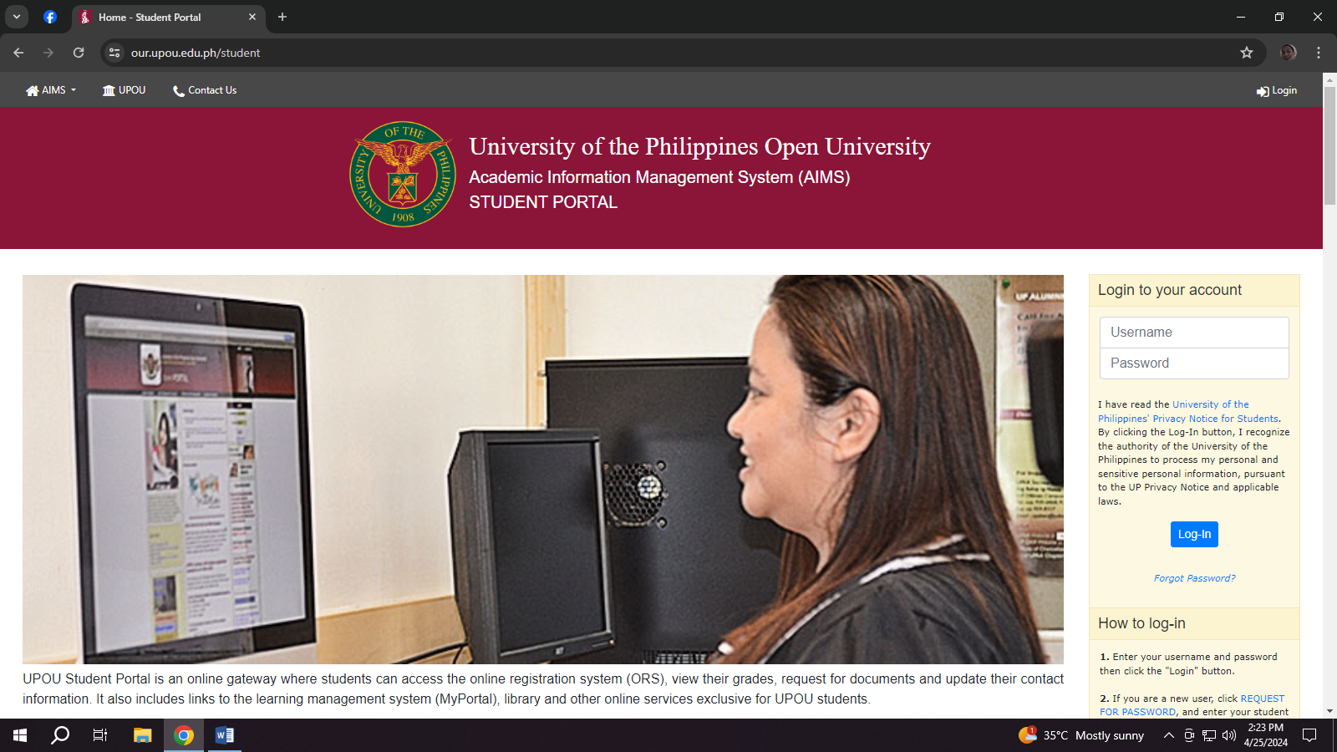This chapter discuss the history and state of the art of the web, web applications and web application vulnerabilities, also relevant literatures were review under the domain of information system security and web application security.

Figure 2.1 : [University of the Philippines Open University (our.upou.edu.ph/student)](https://www.topservelms.com/)

The University of the Philippines Open University (UPOU) website plays a vital role in supporting the university's mission to provide equitable access to quality higher education through open and distance learning modalities.

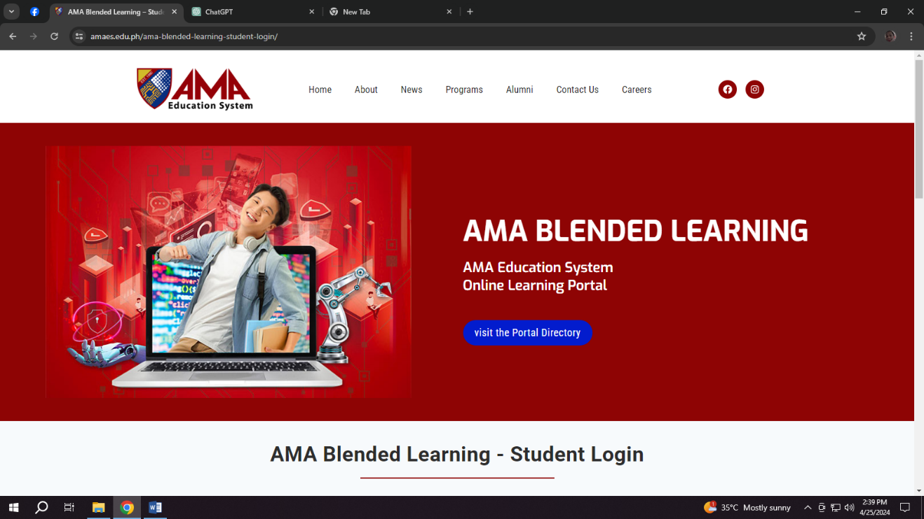

Figure 2.1 : AMA Education System (https://www.amaes.edu.ph/)

The AMA Education System's online learning portal serves as a dynamic platform for delivering high-quality education, fostering student engagement and collaboration, and supporting student success in their academic pursuits..

**CHAPTER 3**

**TECHNICAL BACKGROUND**

**TECHNICALITY OF THE PROJECT**

The proponents have used web-based program wherein the users can access it through any digital platforms. The Information portal management system is an online portal for easy and convenient access by students and staff without using the traditional process communicate with teachers. These are some of the technical terms that are being used in our project: VS Code ­­– Text editor, PHP, HTML, CSS, Apache, DATABASE – Server-client side, Xampp, Javascript – Functionality. Some of the terminologies being stated above are also the technology being used in our project.

**DETAILS OF THE TECHNOLOGY TO BE USED**



Figure 3.3: HTML

HTML stands for hypertext markup language. It’s made of keywords and commands that web designers use for creating websites. Hypertext is text with links that readers can simply click on to go to another page or another part of the page. Meanwhile, markup language uses tags or plain text with special markings to define the sections of a page, such as headers and footers, and other elements, including tables and images.

Figure 3.4: CSS

Cascading Style Sheets, fondly referred to as CSS, is a simple design language intended to simplify the process of making web pages presentable handles the look and feel part of a web page. Using CSS, you can control the color of the text, the style of fonts, the spacing between paragraphs, how columns are sized and laid out, what background images or colors are used, layout designs, variations in display for different devices and screen sizes as well as a variety of other effects.



Figure 3.5: JAVASCRIPT

Web development frequently uses JavaScript, a flexible programming language. It makes websites capable of displaying dynamic content, including interactive elements like form validation, animations, and real-time updates without requiring a page refresh. It makes it easier for users to engage with the LMIS through search searches, form submissions, and real-time updates.



Figure 3.6: MYSQL

MySQL is an open-source relational database management system (RDBMS) that handles data administration and manipulation tasks using Structured Query Language (SQL). Many developers and businesses choose MySQL because of its reputation for dependability, scalability, and user-friendliness. It works effectively for handling user accounts, transactional records, and library catalogs in the LMS.



Figure 3.7: VISUAL STUDIO CODE

Microsoft created Visual Studio Code (VS Code), a free source-code editor for Windows, Linux, and macOS. Code completion, syntax highlighting, debugging, and a number of other enhancements that improve its usefulness for various programming languages and development jobs are supported. Developers use it extensively to write code in many different languages, including JavaScript, Python, Java, and many more. It increases output and makes code optimization and debugging easier for the LMS development process.



Figure 3.9: PHPMYADMIN

MySQL and MariaDB database management can be done with PHPMyAdmin, a free and open-source web-based administration tool. Using an intuitive graphical interface, users may create, delete, change, and query databases, tables, and records, among other database activities, instead of utilizing a command-line interface. Database managers and web developers utilize it extensively to effectively manage their systems. Developers working on the LMIS may better interface with the database and avoid writing complex SQL queries by using PHPMyAdmin, which streamlines database management duties.



Figure 3.9: GOOGLE

Google Chrome browser is a free web browser used for accessing the internet and running web-based applications. The Google Chrome browser is based on the Open Source Chromium web browser project. Google released Chrome in 2008 and issues several updates a year.

**CHAPTER 4**

**Methodology**

**Environment**

**Locale**

The study will be conducted at Cebu Eastern College at the intersection of Dimasalang and Leon Kilat in Cebu City, Philippines. The campus offers kindergarten, elementary, high school and college classes. Additionally, they operate a separate campus on D. Jakosalem that focuses on elementary-level education.

Cebu Eastern College (CEC) is a private, co-educational Chinese-Filipino school in Cebu City. Its roots can be traced to the Cebu Chinese School, founded in 1915, and the Cebu Sun Yat Sen High School, founded in 1925. The school was born as the Cebu Chinese High School out of the merging of the two said schools in 1938. In 1950, the high school earned government recognition as a non-sectarian school, opening its doors to students of all nationalities. Twelve years later, the Chinese High School was renamed to the Cebu Eastern College, at the same time it began developing its college department. Currently, CEC provides basic and higher education programs. It is a K-12 recognized institution, offering the ABM, HUMSS, and STEM strands for interested Senior High School (SHS) students. For college students, the school provides degree courses in Teacher Education, Hotel and Tourism Management, Development Communication, and Information Technology. Cebu Eastern College is one of the oldest Chinese schools in the Philippines and continues to have Chinese classes in its program curricula. Since its establishment, CEC has also been committed to providing the right environment to develop its students holistically in terms of their skills and values. Graduates of Cebu Eastern College become professionals who reflect competence and concern for the community.

**Population Of The Study**

The respondents of the study are the South Bus Terminal Cebu City, which is for passengers, commuters, travelers, and managers who are responsible for overseeing operations and customer service.

|  |  |  |
| --- | --- | --- |
|  | POPULATION | SAMPLE |
| RESPONDENTS | CEC | CEC |
| Teacher | 60 | 30 |
| User | 1000 | 500 |
| Admin | 1 | 1 |
| TOTAL | 1061 | 531 |

Figure 4.0 Population of Study

**Requirement Specification**

**Operational feasibility**

Operational feasibility refers to the practicality and effectiveness of implementing a system within an organization.

Operational feasibility is a measurement of how well a proposed system solves the problem, and takes advantage of the opportunities identified during scope definition and how it satisfies the requirements identified in the requirements analysis phase of system development. One of the tools to be used is the Fishbone Diagram.

**Fishbone Diagram**

The Fishbone diagram identifies many possible causes for an effect or problem. It can be used to structure a brainstorming session. It immediately sorts ideas into useful categories.

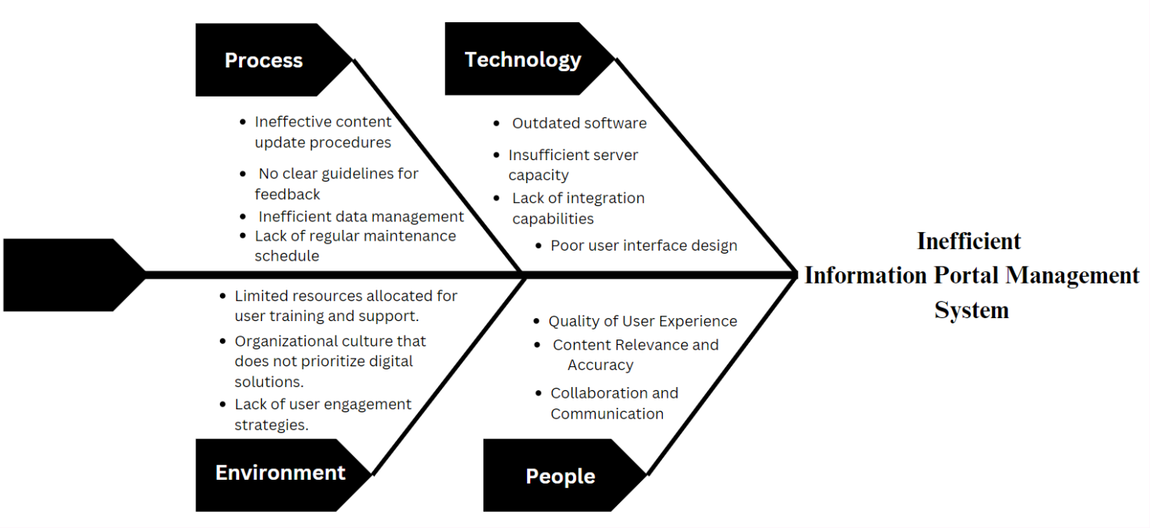

Figure 4.1 Fishbone

**Functional Decomposition Diagram**

Decomposition is the process of starting at a high level and dividing entities into smaller and smaller related parts. Functional decomposition is a business analysis technique for breaking down a "business operation" into functional components. A Functional Decomposition Diagram (FDD) shows a hierarchical organization of the business functions that comprise the business operation.

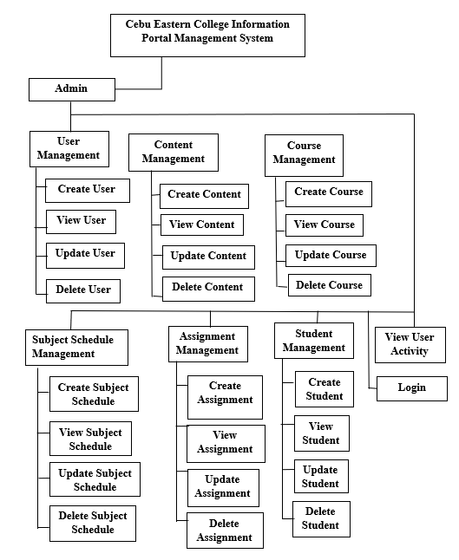

Figure 4.2 Functional Decomposition Diagram (Admin)

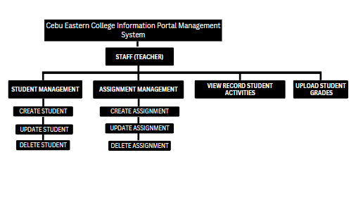Figure 4.2.1 Functional Decomposition Diagram (Teacher)

LOGIN

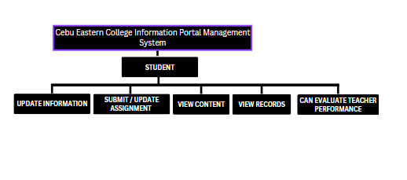

LOGIN

Figure 4.2.2 Functional Decomposition Diagram (Student)

**TECHNICAL FEASIBILITY**

Technical feasibility analysis helps determine if new technology is needed by analyzing the type of technology, what it offers and if current technology can support it. It also measures the benefits of the development and if they are worthwhile to the company of the public.

**Compatibility Checking**

The project will provide a web application using web browsers that are primarily compatible with Internet Explorer and will support adjustments to the Information Portal Management System. An information portal management system must be compatible in order to be implemented and operated successfully within an organization. Hardware compatibility should be evaluated to guarantee that the system will function properly on existing servers, desktops, and mobile devices. Compatibility with the operating system is critical, as the system must be able to run smoothly on common platforms such as Windows, macOS, and Linux. Web browser compatibility is also required to maintain consistent performance across various browsers such as Google Chrome, Mozilla Firefox, and Microsoft Edge.

Database compatibility entails ensuring that the system integrates effectively with the database management system of choice. Network compatibility should be tested to ensure that the system can manage network traffic without generating congestion or performance problems. Furthermore, compatibility with third-party services, should be examined to ensure seamless integration. After a thorough compatibility check, the Cebu Eastern College Information Portal Management System, may be smoothly incorporated into the School Portal infrastructure, assuring efficient operations and school satisfaction.

**Relevance of Technologies**

Developing and maintaining a Cebu Eastern College Information Portal Management System (CECIPMS) involves a range of technologies to ensure functionality, scalability, and ease of use. On the front-end, HTML and CSS are essential for designing the structure and style of the web portal, while JavaScript enables interactive features and dynamic content management. Front-end frameworks like React, Angular, or Vue.js are crucial for building responsive and scalable user interfaces.

MySQL and MariaDB database management can be done with PHPMyAdmin, a free and open-source web-based administration tool. Using an intuitive graphical interface, users may create, delete, change, and query databases, tables, and records, among other database activities, instead of utilizing a command-line interface. Database managers and web developers utilize it extensively to effectively manage their systems. Developers working on the LMIS may better interface with the database and avoid writing complex SQL queries by using PHPMyAdmin, which streamlines database management duties.

**Schedule Feasibility**

Schedule feasibility is defined as the likelihood of completing a project within the time range specified. Schedule feasibility is defined as the likelihood of completing a project by the desired deadline.

The Gantt Chart is an effective tool for arranging the timetable. A Gantt Chart is useful for tracking a project's progress. A Gantt Chart is a form of bar diagram that depicts a project timetable. A Gantt Chart depicts the project's start and finish dates, as well as the terminal and summary sections.

It is an excellent presentation tool for presenting groupings of milestones as well as individual items that are timed. It can also be used in status reporting to demonstrate how much of the plan has been completed by presenting the progress of an activity in the same or parallel bar, or by utilizing color.

**GANNT CHART**

|  |  |  |  |  |  |  |  |  |  |  |  |  |  |  |  |  |  |  |  |  |  |  |  |  |  |  |  |  |  |  |  |  |  |  |  |  |  |  |  |  |  |  |
| --- | --- | --- | --- | --- | --- | --- | --- | --- | --- | --- | --- | --- | --- | --- | --- | --- | --- | --- | --- | --- | --- | --- | --- | --- | --- | --- | --- | --- | --- | --- | --- | --- | --- | --- | --- | --- | --- | --- | --- | --- | --- | --- |
|  | Task Name | Duration | Start | End | Feb 9 – March 8 | | | | | | | | | March 9 –  March 22 | | | | | | | | March 23 – April 20 | | | | | | | | | | | | April 21 --May 21 | | | | | | | | |
|  |  |  |  |  | F | | S | | F | | S | | F | S | F | | S | | F | | S | | F | | S | | F | | S | | F | | S | | | F | | S | | F | | S |
| 1 | Cebu Eastern College Information Portal Management System | 106 days | 02/16/24 | 05/20/24 |  |  | |  | |  | |  | |  | |  |  |  | |  | |  | |  | |  | |  | |  | |  | | |  | |  | |  | |  | |
|  |  |  |  |  |  |  | |  | |  | |  | |  | |  |  |  | |  | |  | |  | |  | |  | |  | |  | | |  | |  | |  | |  | |
|  |  |  |  |  |  |  | |  | |  | |  | |  | |  |  |  | |  | |  | |  | |  | |  | |  | |  | | |  | |  | |  | |  | |
| 2 | 1. **Introduction** | 17 days | 02/16/24 | 03/04/24 |  |  | |  | |  | |  | |  | |  |  |  | |  | |  | |  | |  | |  | |  | |  | | |  | |  | |  | |  | |
|  |  |  |  |  |  |  | |  | |  | |  | |  | |  |  |  | |  | |  | |  | |  | |  | |  | |  | | |  | |  | |  | |  | |
|  |  |  |  |  |  |  | |  | |  | |  | |  | |  |  |  | |  | |  | |  | |  | |  | |  | |  | | |  | |  | |  | |  | |
| 3 | 1.1 Rationale | 3 day | 02/16/24 | 02/19/24 |  |  | |  | |  | |  | |  | |  |  |  | |  | |  | |  | |  | |  | |  | |  | | |  | |  | |  | |  | |
|  |  |  |  |  |  |  | |  | |  | |  | |  | |  |  |  | |  | |  | |  | |  | |  | |  | |  | | |  | |  | |  | |  | |
|  |  |  |  |  |  |  | |  | |  | |  | |  | |  |  |  | |  | |  | |  | |  | |  | |  | |  | | |  | |  | |  | |  | |
| 4 | 1.2 Objectives | 3 day | 02/16/24 | 02/19/24 |  |  | |  | |  | |  | |  | |  |  |  | |  | |  | |  | |  | |  | |  | |  | | |  | |  | |  | |  | |
|  |  |  |  |  |  |  | |  | |  | |  | |  | |  |  |  | |  | |  | |  | |  | |  | |  | |  | | |  | |  | |  | |  | |
|  |  |  |  |  |  |  | |  | |  | |  | |  | |  |  |  | |  | |  | |  | |  | |  | |  | |  | | |  | |  | |  | |  | |
| 5 | 1.3 Scope and Limitations | 71 days | 02/22/24 | 05/04/24 |  |  | |  | |  | |  | |  | |  |  |  | |  | |  | |  | |  | |  | |  | |  | | |  | |  | |  | |  | |
|  |  |  |  |  |  |  | |  | |  | |  | |  | |  |  |  | |  | |  | |  | |  | |  | |  | |  | | |  | |  | |  | |  | |
|  |  |  |  |  |  |  | |  | |  | |  | |  | |  |  |  | |  | |  | |  | |  | |  | |  | |  | | |  | |  | |  | |  | |
| 6 | 1.4 Significance of the Project | 5 days | 02/28/24 | 03/04/24 |  |  | |  | |  | |  | |  | |  |  |  | |  | |  | |  | |  | |  | |  | |  | | |  | |  | |  | |  | |
|  |  |  |  |  |  |  | |  | |  | |  | |  | |  |  |  | |  | |  | |  | |  | |  | |  | |  | | |  | |  | |  | |  | |
|  |  |  |  |  |  |  | |  | |  | |  | |  | |  |  |  | |  | |  | |  | |  | |  | |  | |  | | |  | |  | |  | |  | |
| 7 | 1. **Review of Related Literature and Studies** | 17 days | 03/02/24 | 03/15/24 |  |  | |  | |  | |  | |  | |  |  |  | |  | |  | |  | |  | |  | |  | |  | | |  | |  | |  | |  | |
|  |  |  |  |  |  |  | |  | |  | |  | |  | |  |  |  | |  | |  | |  | |  | |  | |  | |  | | |  | |  | |  | |  | |
|  |  |  |  |  |  |  | |  | |  | |  | |  | |  |  |  | |  | |  | |  | |  | |  | |  | |  | | |  | |  | |  | |  | |
| 8 | 2.1 Review of Related Literature | 3 days | 03/15/24 | 03/18/24 |  |  | |  | |  | |  | |  | |  |  |  | |  | |  | |  | |  | |  | |  | |  | | |  | |  | |  | |  | |
|  |  |  |  |  |  |  | |  | |  | |  | |  | |  |  |  | |  | |  | |  | |  | |  | |  | |  | | |  | |  | |  | |  | |
|  |  |  |  |  |  |  | |  | |  | |  | |  | |  |  |  | |  | |  | |  | |  | |  | |  | |  | | |  | |  | |  | |  | |
| 9 | 2.2 Related Studies | 3 days | 03/15/24 | 03/18/24 |  |  | |  | |  | |  | |  | |  |  |  | |  | |  | |  | |  | |  | |  | |  | | |  | |  | |  | |  | |
|  |  |  |  |  |  |  | |  | |  | |  | |  | |  |  |  | |  | |  | |  | |  | |  | |  | |  | | |  | |  | |  | |  | |
|  |  |  |  |  |  |  | |  | |  | |  | |  | |  |  |  | |  | |  | |  | |  | |  | |  | |  | | |  | |  | |  | |  | |
| 10 | 1. **Technical Background** | 20 days | 03/27/24 | 04/05/24 |  |  | |  | |  | |  | |  | |  |  |  | |  | |  | |  | |  | |  | |  | |  | | |  | |  | |  | |  | |
|  |  |  |  |  |  |  | |  | |  | |  | |  | |  |  |  | |  | |  | |  | |  | |  | |  | |  | | |  | |  | |  | |  | |
|  |  |  |  |  |  |  | |  | |  | |  | |  | |  |  |  | |  | |  | |  | |  | |  | |  | |  | | |  | |  | |  | |  | |
| 11 | 3.1 Technicality of the Project | 3 days | 04/01/24 | 04/04/24 |  |  | |  | |  | |  | |  | |  |  |  | |  | |  | |  | |  | |  | |  | |  | | |  | |  | |  | |  | |
|  |  |  |  |  |  |  | |  | |  | |  | |  | |  |  |  | |  | |  | |  | |  | |  | |  | |  | | |  | |  | |  | |  | |
|  |  |  |  |  |  |  | |  | |  | |  | |  | |  |  |  | |  | |  | |  | |  | |  | |  | |  | | |  | |  | |  | |  | |
| 12 | 3.2 Details of the Technology to be Used | 5 days | 03/28/24 | 04/04/24 |  |  | |  | |  | |  | |  | |  |  |  | |  | |  | |  | |  | |  | |  | |  | | |  | |  | |  | |  | |
|  |  |  |  |  |  |  | |  | |  | |  | |  | |  |  |  | |  | |  | |  | |  | |  | |  | |  | | |  | |  | |  | |  | |
|  |  |  |  |  |  |  | |  | |  | |  | |  | |  |  |  | |  | |  | |  | |  | |  | |  | |  | | |  | |  | |  | |  | |
| 13 | 1. **Methodology** | 24 days | 03/23/24 | 04/05/24 |  |  | |  | |  | |  | |  | |  |  |  | |  | |  | |  | |  | |  | |  | |  | | |  | |  | |  | |  | |
|  |  |  |  |  |  |  | |  | |  | |  | |  | |  |  |  | |  | |  | |  | |  | |  | |  | |  | | |  | |  | |  | |  | |
|  |  |  |  |  |  |  | |  | |  | |  | |  | |  |  |  | |  | |  | |  | |  | |  | |  | |  | | |  | |  | |  | |  | |
| 14 | 4.1 Population of the Study | 4 days | 04/01/24 | 04/03/24 |  |  | |  | |  | |  | |  | |  |  |  | |  | |  | |  | |  | |  | |  | |  | | |  | |  | |  | |  | |
|  |  |  |  |  |  |  | |  | |  | |  | |  | |  |  |  | |  | |  | |  | |  | |  | |  | |  | | |  | |  | |  | |  | |
|  |  |  |  |  |  |  | |  | |  | |  | |  | |  |  |  | |  | |  | |  | |  | |  | |  | |  | | |  | |  | |  | |  | |
| 15 | 4.2 Gannt Chart | 71 days | 04/01/24 | 05/04/24 |  |  | |  | |  | |  | |  | |  |  |  | |  | |  | |  | |  | |  | |  | |  | | |  | |  | |  | |  | |
|  |  |  |  |  |  |  | |  | |  | |  | |  | |  |  |  | |  | |  | |  | |  | |  | |  | |  | | |  | |  | |  | |  | |
|  |  |  |  |  |  |  | |  | |  | |  | |  | |  |  |  | |  | |  | |  | |  | |  | |  | |  | | |  | |  | |  | |  | |
| 16 | 4.3 Use Case | 71 days | 04/01/24 | 05/04/24 |  |  | |  | |  | |  | |  | |  |  |  | |  | |  | |  | |  | |  | |  | |  | | |  | |  | |  | |  | |
|  |  |  |  |  |  |  | |  | |  | |  | |  | |  |  |  | |  | |  | |  | |  | |  | |  | |  | | |  | |  | |  | |  | |
|  |  |  |  |  |  |  | |  | |  | |  | |  | |  |  |  | |  | |  | |  | |  | |  | |  | |  | | |  | |  | |  | |  | |
| 17 | 4.4Functional Decomposition Diagram | 71 days | 04/01/24 | 05/04/24 |  |  | |  | |  | |  | |  | |  |  |  | |  | |  | |  | |  | |  | |  | |  | | |  | |  | |  | |  | |
|  |  |  |  |  |  |  | |  | |  | |  | |  | |  |  |  | |  | |  | |  | |  | |  | |  | |  | | |  | |  | |  | |  | |
|  |  |  |  |  |  |  | |  | |  | |  | |  | |  |  |  | |  | |  | |  | |  | |  | |  | |  | | |  | |  | |  | |  | |
| 18 | 4.5 Fishbone | 4 days | 04/01/24 | 04/05/24 |  |  | |  | |  | |  | |  | |  |  |  | |  | |  | |  | |  | |  | |  | |  | | |  | |  | |  | |  | |
|  |  |  |  |  |  |  | |  | |  | |  | |  | |  |  |  | |  | |  | |  | |  | |  | |  | |  | | |  | |  | |  | |  | |
|  |  |  |  |  |  |  | |  | |  | |  | |  | |  |  |  | |  | |  | |  | |  | |  | |  | |  | | |  | |  | |  | |  | |
| 19 | 4.6 UI | 2 days | 04/05/24 | 04/06/24 |  |  | |  | |  | |  | |  | |  |  |  | |  | |  | |  | |  | |  | |  | |  | | |  | |  | |  | |  | |
|  |  |  |  |  |  |  | |  | |  | |  | |  | |  |  |  | |  | |  | |  | |  | |  | |  | |  | | |  | |  | |  | |  | |
|  |  |  |  |  |  |  | |  | |  | |  | |  | |  |  |  | |  | |  | |  | |  | |  | |  | |  | | |  | |  | |  | |  | |
| 20 | 4.7 Activity Diagram | 71 days | 04/01/24 | 05/04/24 |  |  | |  | |  | |  | |  | |  |  |  | |  | |  | |  | |  | |  | |  | |  | | |  | |  | |  | |  | |
|  |  |  |  |  |  |  | |  | |  | |  | |  | |  |  |  | |  | |  | |  | |  | |  | |  | |  | | |  | |  | |  | |  | |
|  |  |  |  |  |  |  | |  | |  | |  | |  | |  |  |  | |  | |  | |  | |  | |  | |  | |  | | |  | |  | |  | |  | |
|  |  |  |  |  |  |  | |  | |  | |  | |  | |  |  |  | |  | |  | |  | |  | |  | |  | |  | | |  | |  | |  | |  | |

Figure 4.3 Gantt Chart

**Economic Feasibility**

Evaluating the economic feasibility of implementing an Cebu Eastern College Information Portal Management System (CECIPMS) is crucial to ensure that the benefits outweigh the costs. The analysis begins with understanding the various costs involved. Development costs include expenses for software development, licensing, and the salaries of developers and IT staff. Additionally, there are hardware costs for servers, networking equipment, and other necessary infrastructure. Implementation costs cover the installation of the system, data migration, and staff training. Ongoing maintenance and support costs must also be factored in, encompassing system updates and technical support.

A comprehensive cost-benefit analysis is essential. An CECIPMS can significantly increase operational efficiency by streamlining information management and reducing administrative workload. Improved access to comprehensive and up-to-date information can enhance decision-making processes, potentially leading to cost savings and increased revenue. The system can also foster better communication and information sharing among stakeholders, leading to more coordinated and efficient operations. Additionally, digitizing documents can reduce costs associated with paper usage, printing, and physical storage.

**Cost of Application**

Based from the observation of the researchers, the project will have no cost during implementation since the Cebu Eastern College already have the needed equipment for the Web Application of the project such as desktop computer and internet connection.

Since not all people today have desktop computers, it will be the responsibility of the users to ensure they have access to alternative devices, such as mobile phones, which are more commonly owned.

Implementing an Information Portal Management System (IPMS) involves various costs, which can be categorized into development, implementation, and ongoing maintenance. A thorough understanding of these costs is crucial for budgeting and financial planning.

**Benefits of Application**

* Single Point of Access: An IPMS provides a centralized platform where users can access all necessary information, documents, and resources from a single interface. This eliminates the need to search through multiple systems or locations.
* Time Savings: By providing quick access to information and resources, employees can spend less time searching for data and more time on their core responsibilities.
* Real-Time Information: Access to up-to-date information ensures that decisions are based on the most current data available.
* Scalable Solutions: An IPMS can grow with the organization, allowing for the addition of new features and capabilities as needed.
* Customization: The system can be tailored to meet the specific needs and workflows of the organization, providing flexibility in its implementation and use.
* Intuitive Interface: Modern IPMS solutions offer user-friendly interfaces that make it easy for employees to navigate and use the system effectively.
* Personalization: Users can often customize their dashboards and access settings to suit their individual preferences and work habits.

**Requirements Modeling**

The purpose of this study is to develop a Web-based of Cebu Eastern College Information Portal Management System.

The functional requirements of proposed study are to develop a Web application that will be useful for the users.

**Non – Functional Requirements**

* The Web-application should be able to run on the website.
* Web applications will have a friendly user interface.
* The application shall have an effectiveness, efficiency and satisfaction.

**Input**

* Users input their student id preferences by browsing through the school portal and viewing their school activities.
* Invalid accounts can’t access and users will be prompted to provide correct information for successful login.
* Admin input parameters for generating reports and analyzing data related to user activity.

**Process**

* The Admin analyzes data collected from user interactions and feedback to generate reports and gain insights into user behavior and preferences.
* Users can access and view their school activities.

**Output**

* Users that are logged in can view necessary features of Web-based Application.
* Users input information for account management purposes, such as updating personal profiles, viewing assignment history.

**Performance**

* The Web-based application can give feedback to the user if there’s a problem or need maintenance.
* The Web-based application is expected to respond to users due to low connection.

**Control**

* Only the admin can manage users, and can manage all the functionalities of the web application.

**Object Modeling**

**Use Case Diagram**

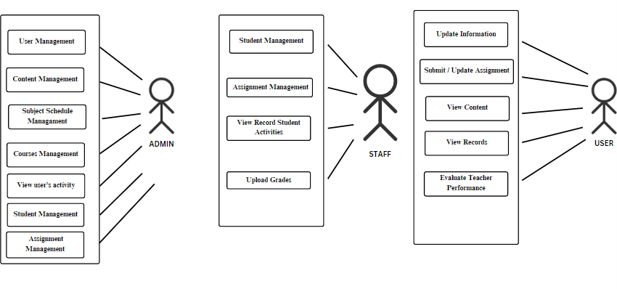

Figure 4.4 Use Case Diagram for Cebu Eastern College Information Portal Management System

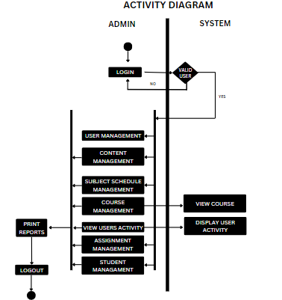

Figure 4.5 Activity Diagram Cebu Eastern College Information Portal Management System

(Admin)

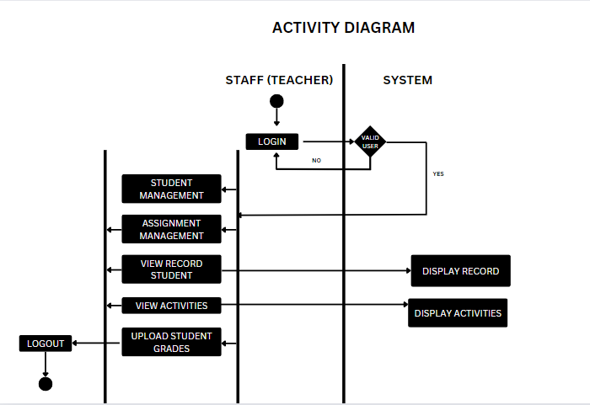

Figure 4.5.1 Activity Diagram Cebu Eastern College Information Portal Management System

(Teacher)

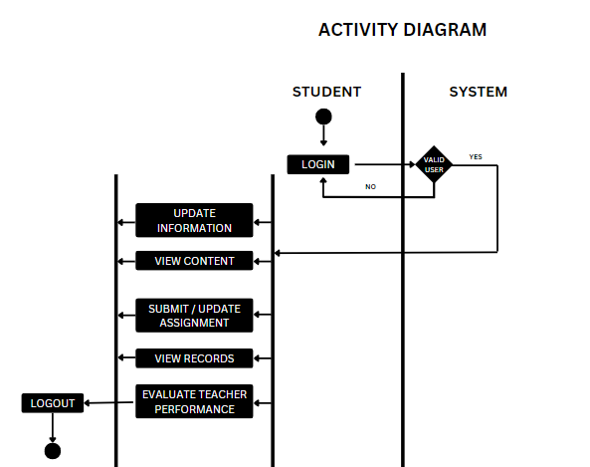

Figure 4.5.2 Activity Diagram Cebu Eastern College Information Portal Management System

(Student)

**Design**

**Output and User-Interfacing Design**

The picture shows the Graphical User Interface of the proposed Cebu Eastern College Information Portal Management System

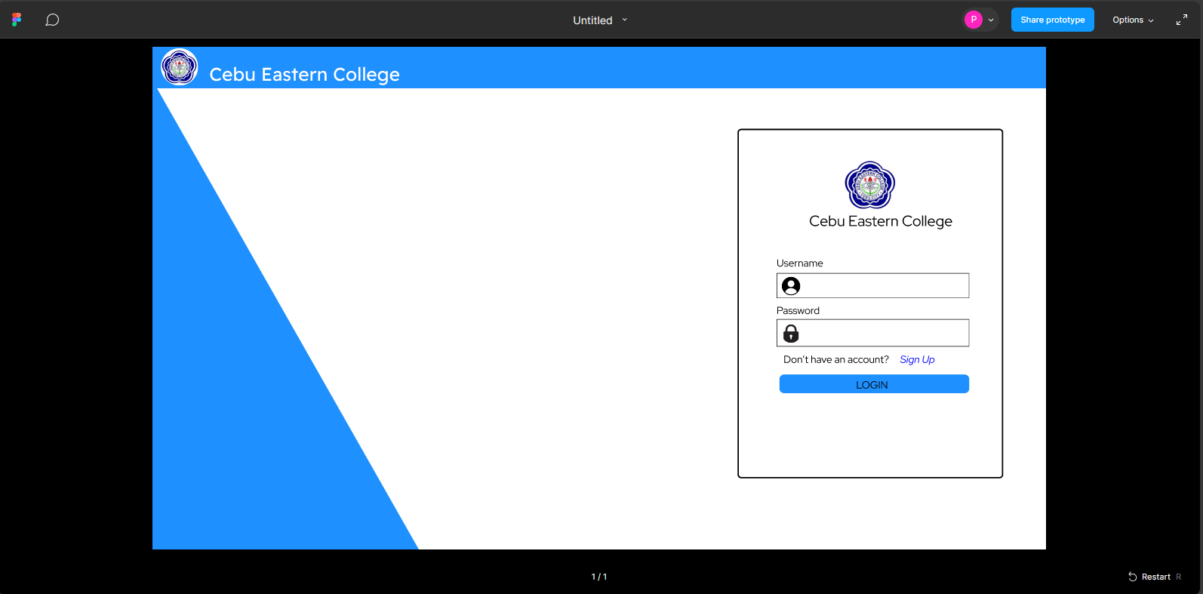

Figure 4.6 A screenshot of Front Page of the Cebu Eastern College Information Portal Management System

**Network Model** is a conceptual representation of how data is structured and organized within a database, defining the relationships between different data elements. It typically consists of nodes (entities) and edges (relationships) that connect these nodes, illustrating the flow and connections of information.

Advantages of Network Model are the following:

Flexibility: Unlike the hierarchical model, which organizes data in a tree-like structure, the network model allows for more flexible relationships between entities.

Capability to Handle more relationship types: The network model can handle one to one and many to many N: N relationship.

Efficient Data Retrieval: In the network model, data access is facilitated through pointers or links between records.

Data Integrity: The network model supports data integrity constraints, ensuring that relationships between entities remain valid.

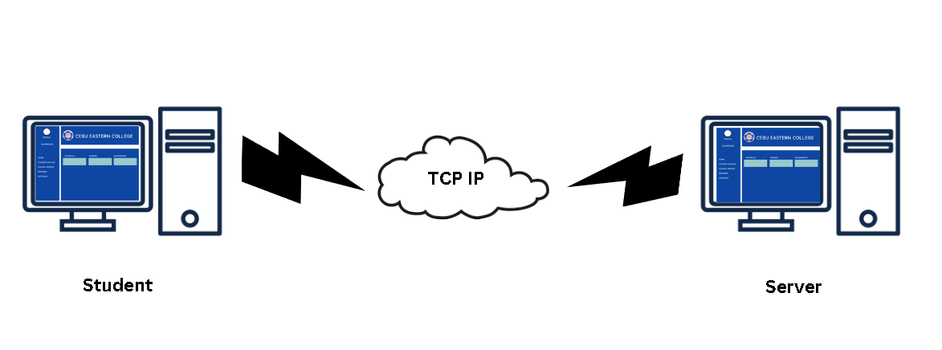

Figure 4.7 Internet Network Model

**Network Topology** refers to the arrangement of nodes and connections in a computer network. It defines how devices such as computers, printers, and servers are organized and interconnected. Common topologies include bus, star, ring, and mesh, each with its advantages and disadvantages in terms of cost, scalability, and fault tolerance. Understanding network topology is crucial for designing, managing, and troubleshooting networks effectively.

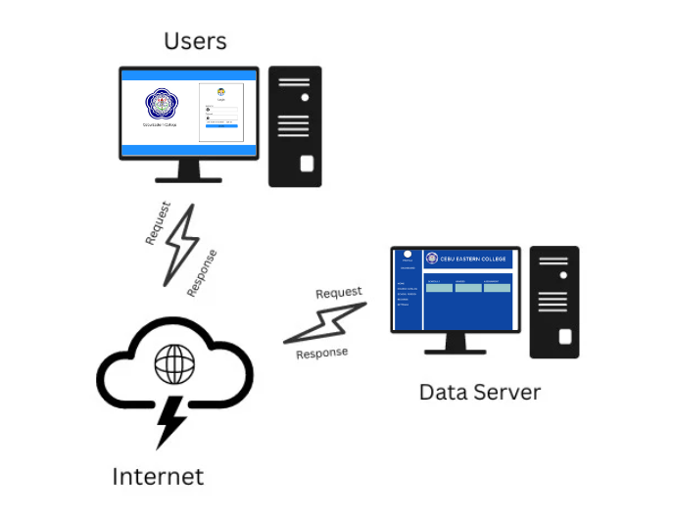

Figure 4.8 Network Topology

**Security**

This system measures to protect the system, its users, and the data it handles. Data Encryption uses encryption protocols such as HTTPS to encrypt data transmitted between users' devices and the cafeteria system's servers. This ensures that sensitive information, such as login credentials and payment details, is protected from interception by unauthorized parties. Authentication and Authorization: Implement strong authentication mechanisms, such as multi-factor authentication (MFA), to verify the identity of users accessing the system. Additionally, enforce proper authorization controls to ensure that users can only access the data and functionalities appropriate to their roles.

**Development**

The software specification outlines the detailed functionality, performance, and constraints of the system to guide its development and implementation. Our project describes the needs of the users to solve reservation problem. The Cebu Eastern College Information Portal Management System

is intended for Passengers, Commuters, etc. Upon developing the Web application, the software needed for the application to run must be Visual Studio or other code editors.

In the part of the server, the proponents choose the widely known PHP language in developing it. Furthermore, a wide range of text editing tools is available to choose from. With all of the variety of code editors, like Visual Studio and Notepad++ was utilized to develop the Server. Notepad++ runs on most operating systems, to be more concise, on windows platforms. In relation to the windows platform, the proponents also chose Microsoft windows Operating systems which ranges from XP up until the newest version, to be the platform for the server and therefore it is efficient to use.

**Hardware specifications**

Hardware specifications for the online cafeteria system at Cebu Eastern College, it's crucial to ensure reliability, performance, and scalability. The server infrastructure should be robust enough to handle concurrent user requests during peak hours without significant slowdowns. High-speed internet connectivity is essential to ensure seamless communication between the users' devices and the system's servers. Backup power sources, such as uninterruptible power supplies (UPS), should be in place to prevent data loss and ensure system availability in the event of power outages. Redundant storage solutions, such as RAID arrays, can enhance data resilience and availability. Additionally, network security measures, including firewalls and intrusion detection/prevention systems, should be implemented to protect the system from cyber threats. Regular maintenance and monitoring of hardware components are necessary to detect and address any issues promptly. Collaboration with IT professionals and vendors can help ensure that the hardware infrastructure meets the system's requirements and supports its seamless operation. On the part of web server to make the staff satisfied in working, these are the hardware materials to be used:

● System Unit

● Keyboard

● Monitor

● Mouse

**Programing Environment**

Front end and back end can be carefully selected to meet the institution's specific needs, considering factors like scalability, ease of development, and compatibility.

Front-end is the development of the graphical user interface of a website through the use of HTML, CSS, and JavaScript so users can view and interact with that website. Back-end developer writes code that forms the backbone of a website or app. Front End The front end is responsible for presenting information to users in a visually appealing and intuitive manner, facilitating user interaction and engagement with the application. Back End. Back-end development often involves using server-side programming languages such as JavaScript (with Node.js), Python (with frameworks like Django or Flask), Ruby (with Ruby on Rails), Java, or PHP.